Scott County Fiscal Court held a meeting on Friday, December 27, 2024. Judge Covington called the meeting to order. Present were Magistrates Mr. Hostetler, Mr. Jones, Mr. Wallace, Mr. Corman, Mr. Ellison, Mr. Pratt, Mr. Livingston, and County Attorney, Cam Culbertson.
Judge Covington requested a moment of silence to honor Trina Jenkins.
A motion was made by Mr. Corman with second by Mr. Hostetler to approve the previous meeting minutes. Court voted unanimous.
A motion was made by Mr. Livingston with second by Mr. Hostetler to approve the following transfers. Court voted unanimous.
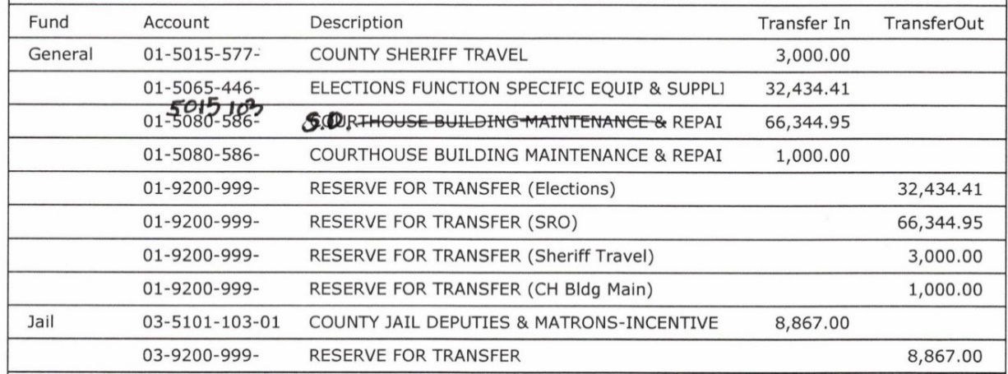
A motion was made by Mr. Livingston with second by Mr. Hostetler to approve the bills as presented and the following hand check. Court voted unanimous.
Jail Fund/ General $300,000.00
Mr. Culbertson gave second reading of Ordinance 24-11; an ordinance amending Article II of the Georgetown-Scott County Zoning Ordinance regarding medicinal cannabis business operations. Planner, Rhett Shirley was available for questions. A motion was made by Mr. Livingston with second by Mr. Jones to approve second reading. Court voted unanimous.
Mr. Culbertson gave second reading of Ordinance 24-12; an ordinance related to changing the zone for 5.00 acres, more or less, owned by Two Alpha LLC, said property situated on Industry Road at Parcel 185-30-009.002 from A-1 (agricultural) to I-1 (light industrial). A motion was made by Mr. Corman with second by Mr. Hostetler to approve second reading. Court voted unanimous.
Jailer, Derran Broyles submitted an updated Standard Operating Procedures (SOP) manual including a few minor changes and the addition of NET services. Mr. Livingston suggested a one word edit on page 46 (his --> their); Jailer Broyles stated he will make that change. A motion was made by Mr. Livingston with second by Mr. Ellison to approve the updated SOP. Court voted unanimous.
Mr. Culbertson read Resolution 24-28; a resolution related to the creation of a moratorium on the Georgetown-Scott County Planning Commission’s acceptance and review of applications for the establishment of RV campgrounds. In order to research the issues and draft proposed regulations, a minimum period of six months is necessary. Scott County citizen Richard “Dick” Murphy thanked the court for this action but hoped it would be longer than six months; Mr. Hostetler clarified it is a minimum of six so it can be extended if necessary. A motion was made by Mr. Jones with second by Mr. Pratt to approve the resolution. Court voted unanimous.
EMS Director, Chris Runyon requested to hire Hunter Hill, Madalene Evans, and Junior Morales full-time at $14.14 per hour. A motion was made by Mr. Hostetler with second by Mr. Corman to approve the new hires. Court voted unanimous.
A motion was made by Mr. Hostetler with second by Mr. Jones to adjourn. Court voted unanimous.

