Legistar Approving Agenda Items/Files
Providence, RI

Overview
This quick reference guide provides instructions on how to review and Approve Agenda Items/Files. Most Files require review and approval prior to being added to an Agenda. Approvers will log into Legistar to review a File and act on it. Within the Legistar workflow, anyone who is part of an approval workflow is called an “Approver”.
Step 1: Reviewing an Agenda Item/File in Legistar
- From the Home module, select the File to review and approve by double-clicking the item from the Approval Requests pane in the lower right quadrant of the screen. You will be taken to the Approval Tracking tab.
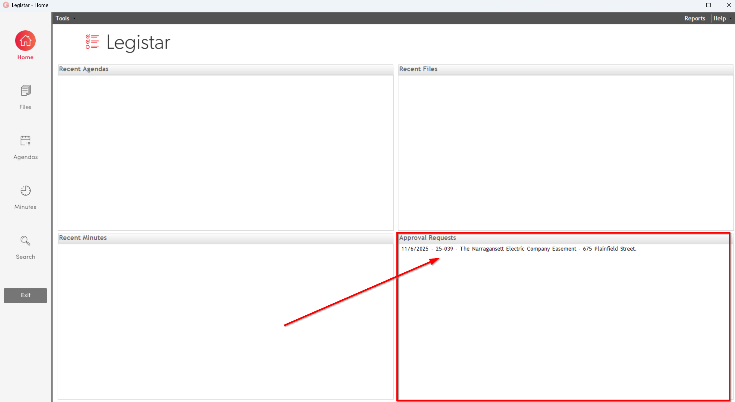
- If applicable, review the Type, Meeting Type, and Agenda Date fields at the top of the screen. If you are not the first Approver in the sequence, you can also review any notes or actions from previous Approvers on the Approver Action tab. If you are the first Approver, there will not be any Approver or workflow history to review yet.

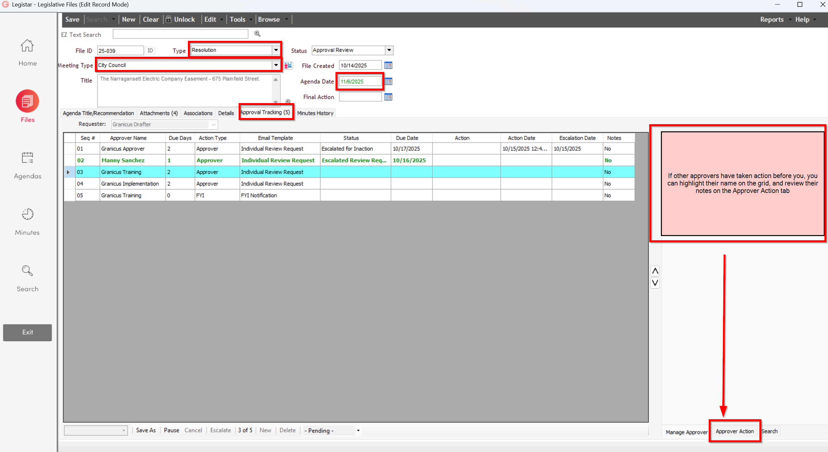
- Click the Agenda Title/Recommendation tab. You can review the Agenda Item text by scrolling through the window at the bottom of the screen. If edits to the Text File are required, click Edit to access and open the Microsoft Word template to make changes. When changes are complete, click the Save icon in Word and close out of Word to save your changes to Legistar and return to the Files module.
NOTE: If changes are made to the ..title section of the template, a pop-up box appears asking you to confirm the Title changes. Click OK to continue and update the Title field with the new template text.
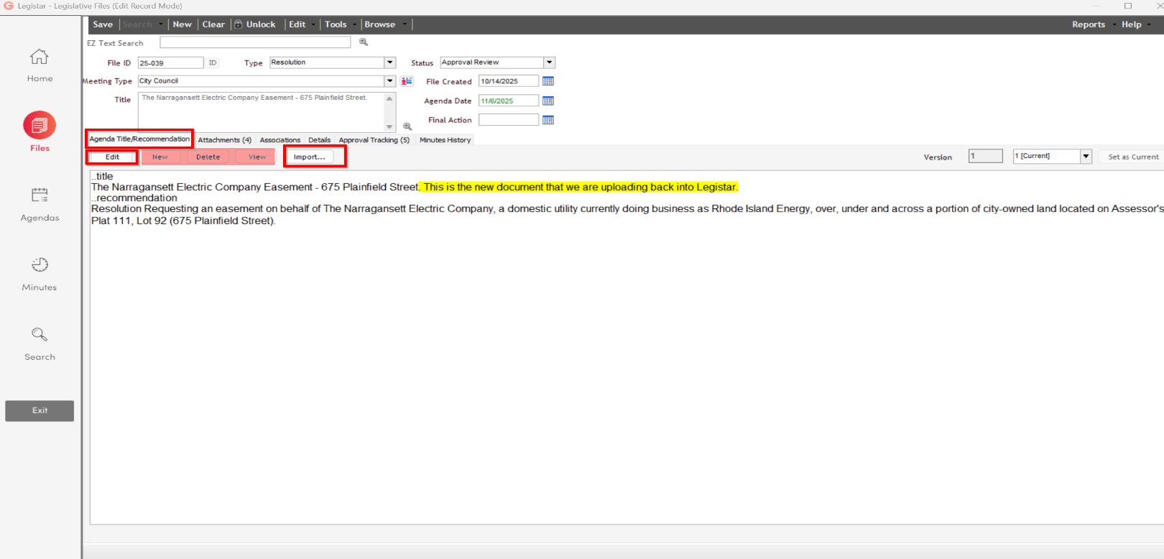
NOTE: It may also be possible for Approvers to Import a new version of the Text File, rather than update the existing Text File. Please see Step 2, Option 2 of the Providence, RI Drafting Guide for instructions to Import a new Text File.

- Click the Attachments tab to review the attached documentation. To open a document, double-click on the attachment name in the grid, or highlight the attachment and click Launch from the bottom left toolbar.
After opening or launching an editable format attachment, you can edit the document. To save your changes back to Legistar, click the Save icon and close out of the attachment.
NOTE: Changes made to attachments in Legistar do NOT update the local copy saved to your local drive.
Other actions you can take on this tab are:
  - Click Attach to add additional documentation.
  - Rename attachments in the Name field, then click the Update Attachment Details button.
  - Update or add notes for a specific attachment in the Internal Notes field, then click the Update Attachment Details button.
  - Replace attachments with the Replace button.
  - Delete attachments by clicking the Remove button; the arrow on this button will also give you the option to Remove All attachments at once.
  - Reorder the attachments list with the up and down arrows next to the grid.
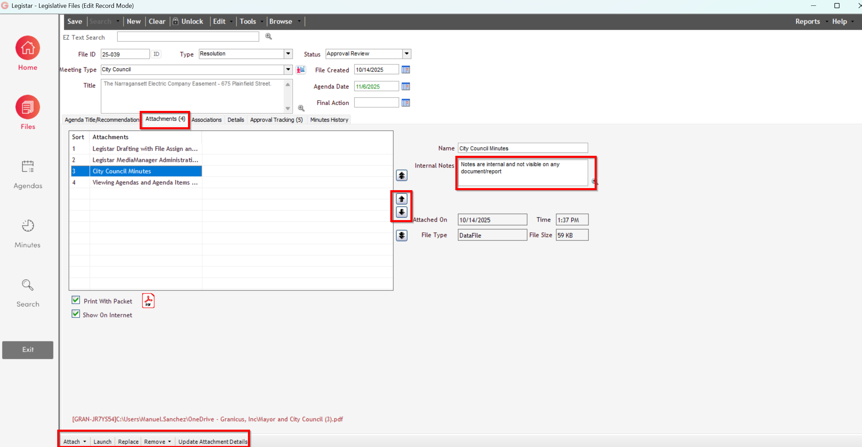
- Click the Associations tab to review any potential selections. If any Associations need to be added or removed, click Edit for that section, move Associations left or right as needed. Click Save, then Close.
- Review the Details tab for any pertinent information. Update the tab as needed.

Step 2: Acting on a File
After reviewing a File and making any potential edits, Approvers are ready to act on the File. The actions Approvers can take are [Approving, Disapproving, or Delegating]. Each Approver can only take one action.

Approving a File
To Approve a File:
- Click the Approval Tracking tab in the lower right when you are done reviewing and editing and are ready to act on the Agenda Item. Confirm that your name is green in the list, indicating that you are the active Approver. Highlight your name in the grid with a single click.
- Click the Approver Action tab in the lower right. From this tab you can enter a Note (optional for Approving), then click the Approve button to approve the File. Click Yes in the confirmation pop-up to complete your Approver Action.
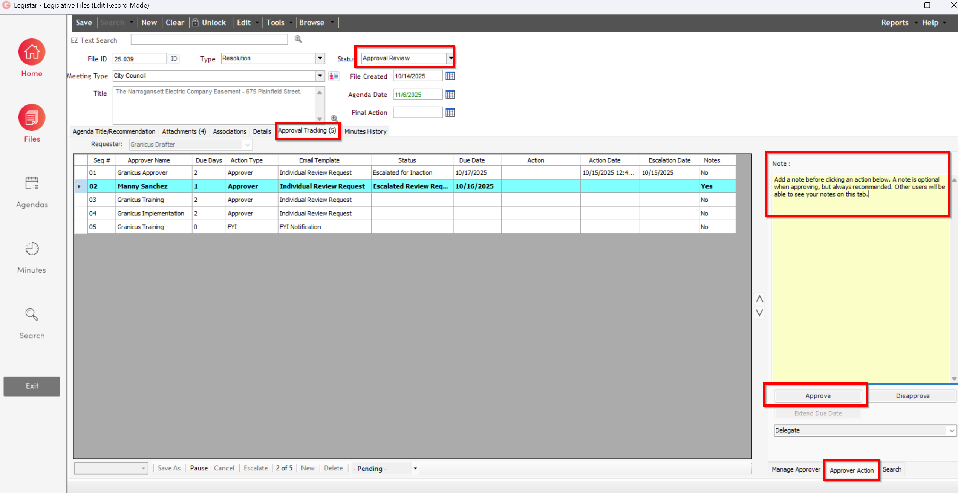
After you confirm your action, you can no longer edit this File. If there are more Approvers after you, the status of the File will remain Approval Review and the next Approver in the sequence is the only Approver that has access to edit and act on the File or Approval Sequence.
If you were the last Approver in the sequence, the status of the item will change to Agenda Ready.

Disapproving a File
If you Disapprove a File, Legistar requires you to enter notes about why you’re disapproving the Agenda Item. The status of the File will change back to Draft. Legistar will send emails to the Drafter and previous Approvers informing them that the File has been Disapproved. After the Drafter has received the disapproved Agenda Item back, they can read the Approvers’ notes, make the necessary changes, add a new Approval Sequence, and re-submit the File for approval. To Disapprove a File:
- On the Approval Tracking tab, click the Approver Action tab in the lower right. Confirm that your name is green in the list, indicating that you are the active Approver. Highlight your name in the grid with a single click.
- Entering a Note is required when Disapproving. In the Notes field, enter details as to why you are disapproving and what changes need to be made. Be as detailed as possible.
- Click the Disapprove button.
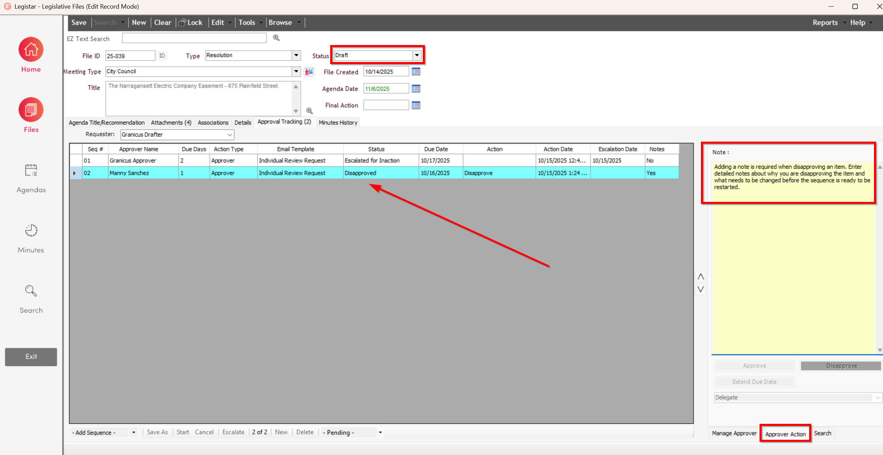
- Click Yes at the confirmation pop-up message. The status will change from Approval Review to Draft, and the Drafter will be notified via email. The Drafter will be in control of the File until a new Approval Sequence is started.
NOTE: Any Approvers who were coming up in the sequence and had not yet been notified of the Agenda Item will be removed from the workflow. Only Approvers who had previously taken an action will have their historical record and notes retained in the workflow grid.

Delegating a File
Approvers can Delegate their turn to review, edit, and take an action on the Agenda Item to another eligible Approver in the database. To Delegate a File:
- On the Approval Tracking tab, click the Approver Action tab in the lower right. Confirm that your name is green in the list, indicating that you are the active Approver. Highlight your name in the grid with a single click.
- Entering a Note is optional when Delegating; however, it is highly recommended to provide the delegate Approver with as much information as possible. In the Notes field, enter details about why you’re delegating the Agenda Item and any applicable instructions.
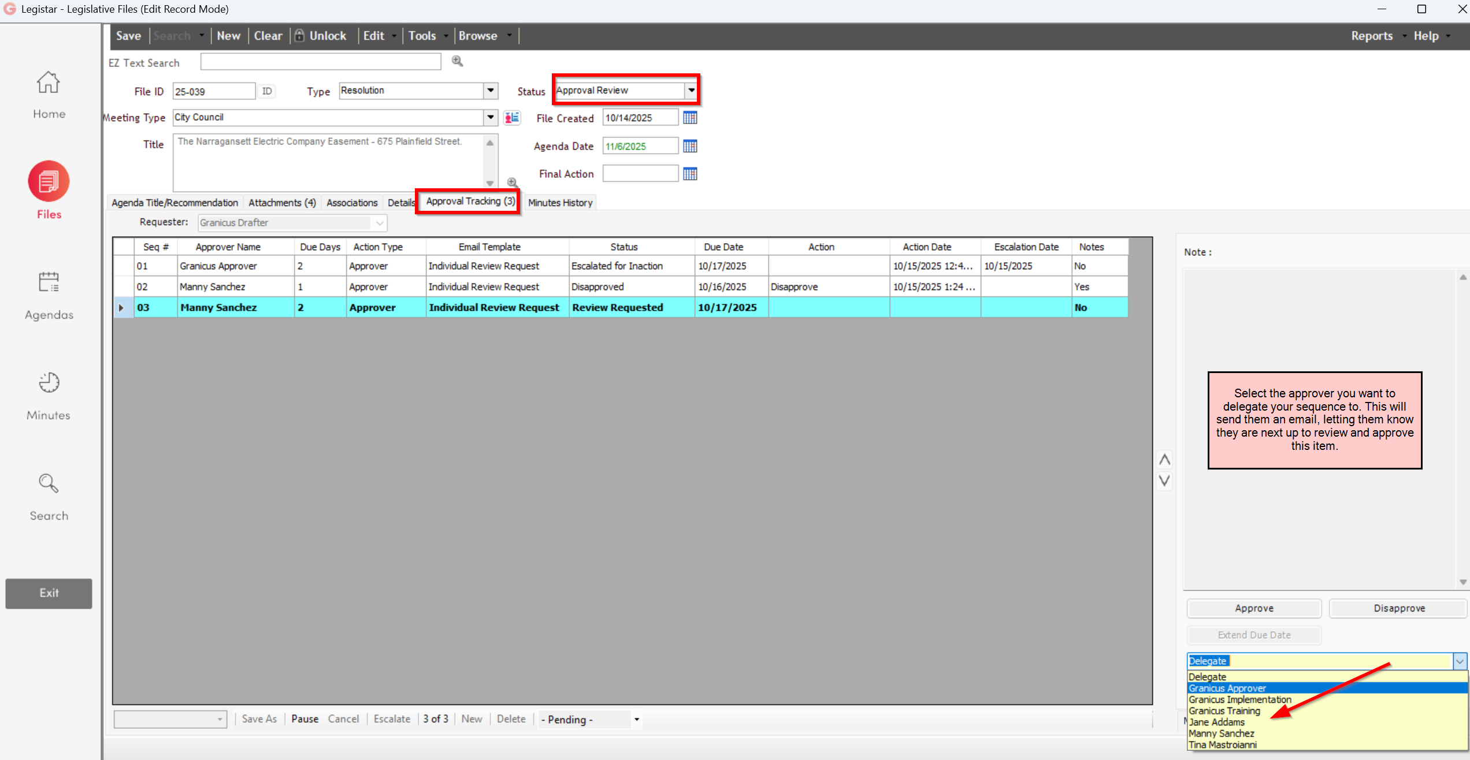
- Use the Delegate drop-down menu to select the desired delegate Approver.
- Click Yes at the confirmation window. The new Delegate Approver will appear in the grid as the active Approver, and the former Approver will have a record that their turn is complete. The Drafter and newly delegated Approver will receive emails about the delegation.

After you confirm your action, you can no longer edit this File. The status of the File will remain Approval Review and the Delegate Approver in the sequence is the only Approver that has access to edit and act on the File or Approval Sequence.
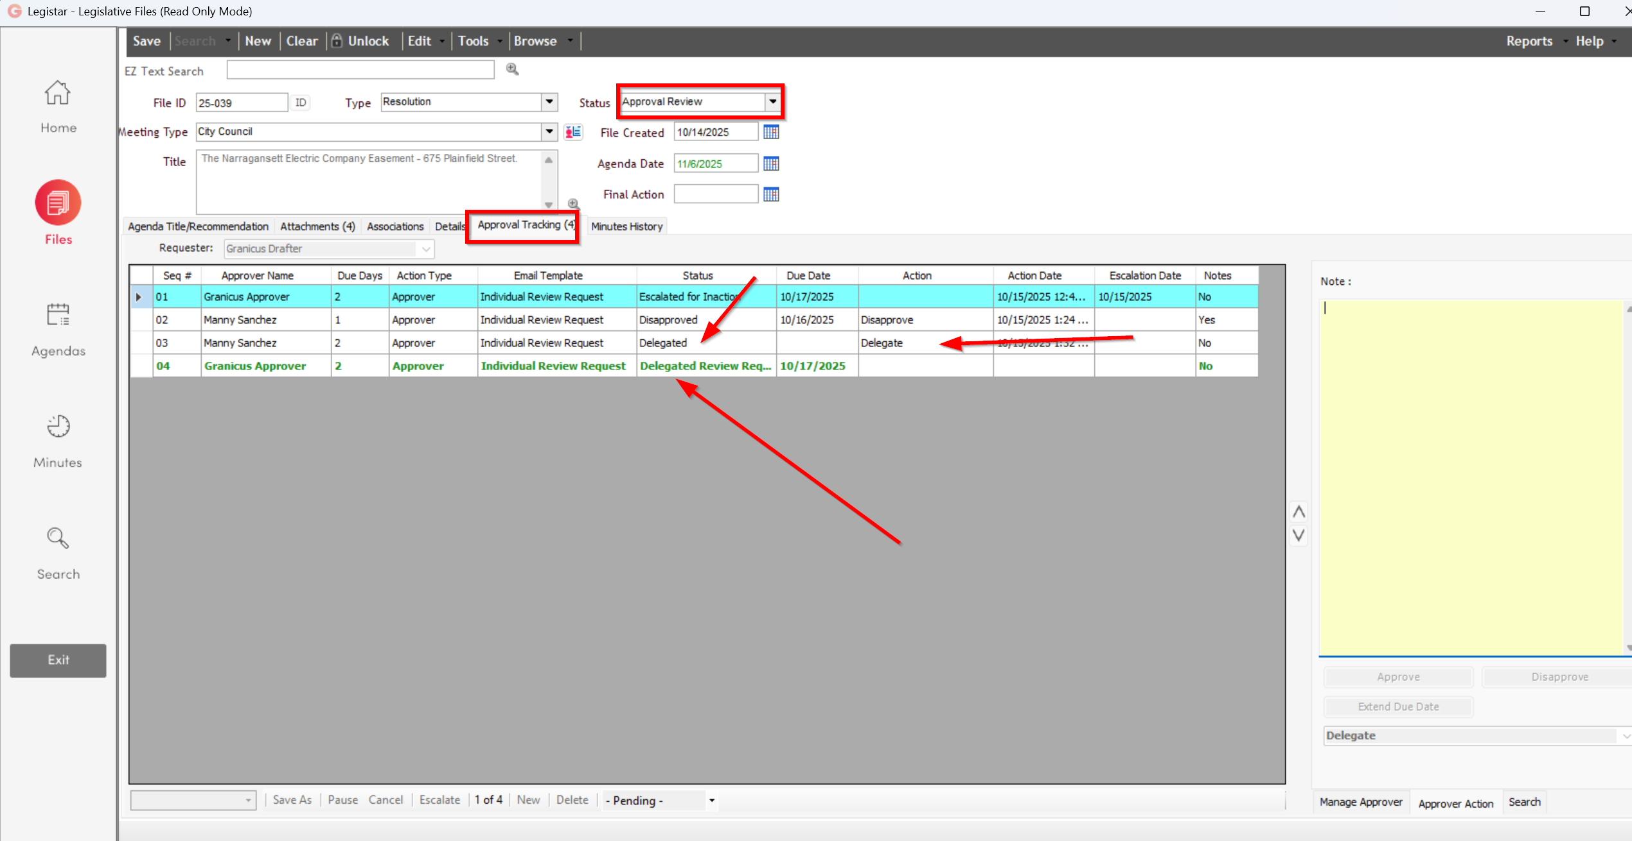

Reviewing a File on the Web
As an alternative to logging into Legistar, reviewers can access a web-based reviewer screen on your public facing InSite webpage.

- Navigate to your InSite webpage by clicking the link in your approval notice email or by entering the web address in your browser: https://providenceri.legistar.com/ (remember to leave off the "www").
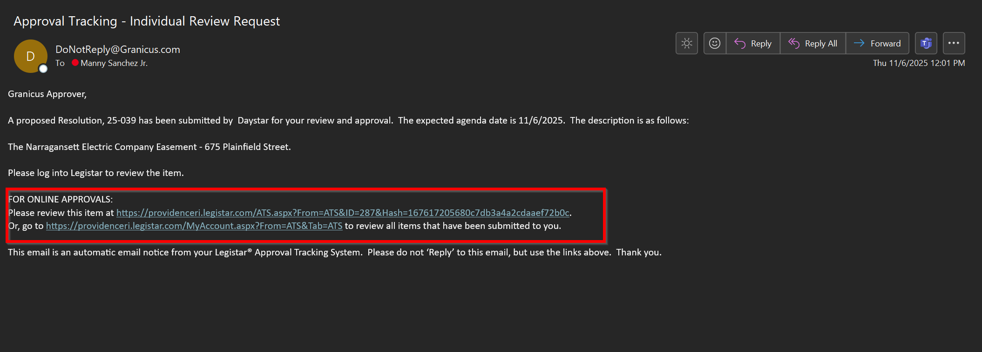
- Sign in after clicking the link or click Sign In in the top right corner using your Legistar Username and Password if you did not click the link from the email.
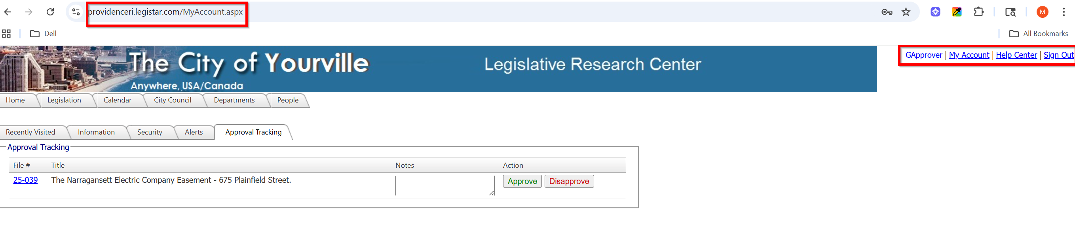
- Click the Approval Tracking tab. If you don’t see that tab, click the My Accounts link in the top right corner to pull it up.
- You can click Approve or Disapprove from this page if you're already familiar with the contents of the file. If you need to review the file, click the File ID of the item you would like to review.
- Review the information on the screen. Please note that some of the InSite language is different from the language in your Legistar Files Module
- To make changes to the Staff Report using Microsoft Word, Click Download Word document to view the Agenda Item Body text and other item details.
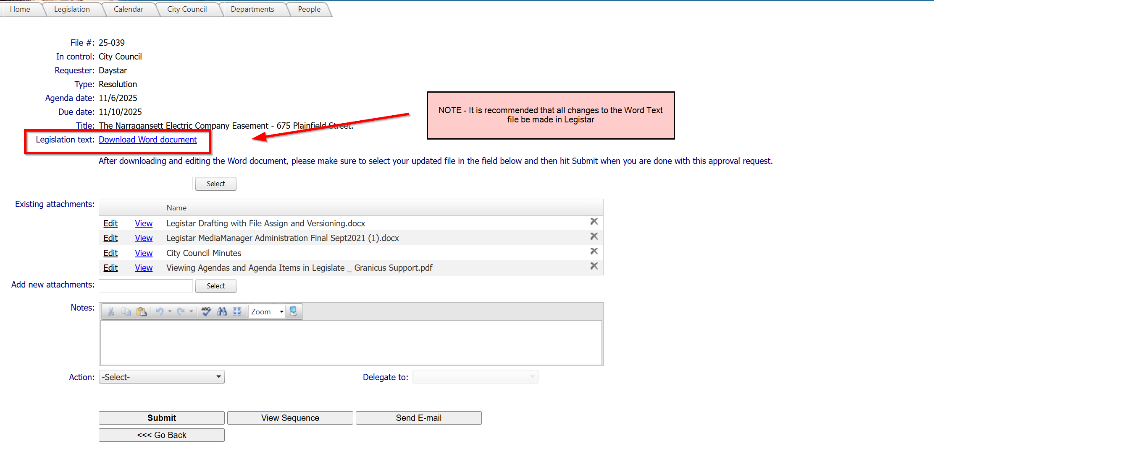

  - Once the Word document downloads, you can review the Agenda Item Body details. It is recommended that changes to the Microsoft Word document (Agenda Title/Recommendation) only be made in Legistar, and not via the website.
  - If changes are made to the Word Document, you will need to Save the edited document to your local device and then upload the updated Word document by clicking Select, navigating to your file, then selecting Open.
  - If you upload a new Word Document, you must choose an action, then click Submit at the bottom of the page for the changes to be reflected in Legistar.
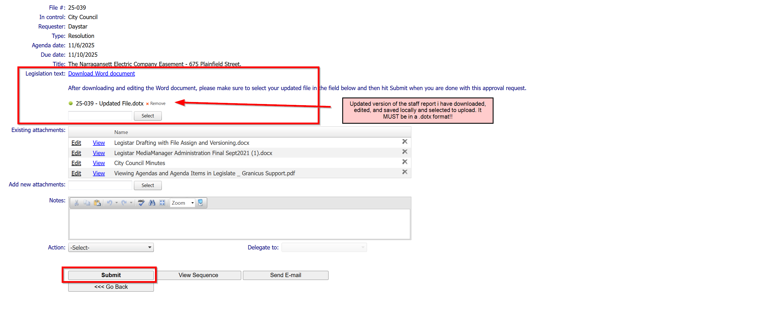
  - Click View to review attachments.
  - Click Edit to modify attachment names.
  - If you make any changes to an existing attachment or need to upload a new attachment, do so using the Add new attachments field. Delete the existing attachment by clicking the X at the end of the Existing Attachments grid.

NOTE: If you upload a new attachment, you must choose an Action, then click Submit for the changes to reflect in Legistar. (see photo below)
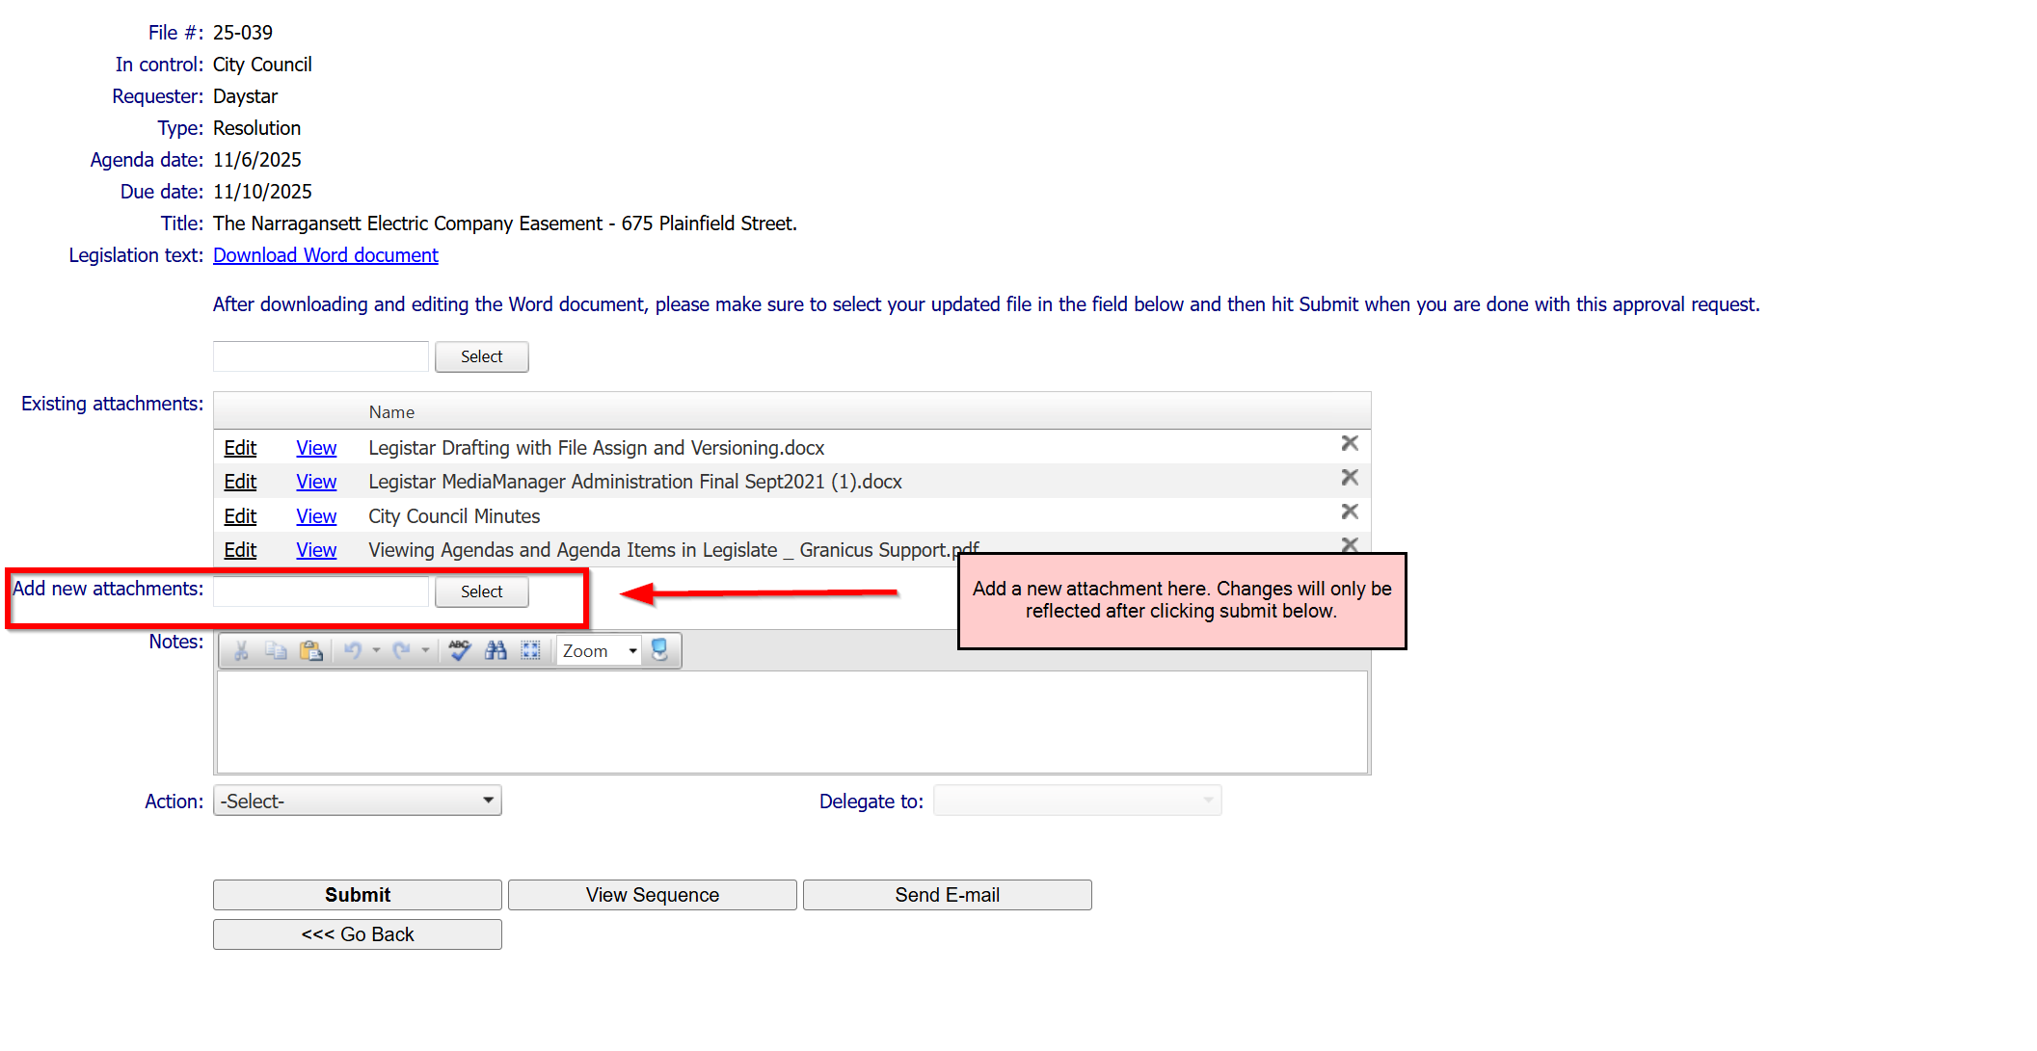

- Enter any Notes if needed. You must enter a Note before selecting an Action.
- Use the Action drop-down menu to select your approval action: Approve, Delegate or Disapprove. Extend Due Date is not an option for Approvers.
- Click Submit.

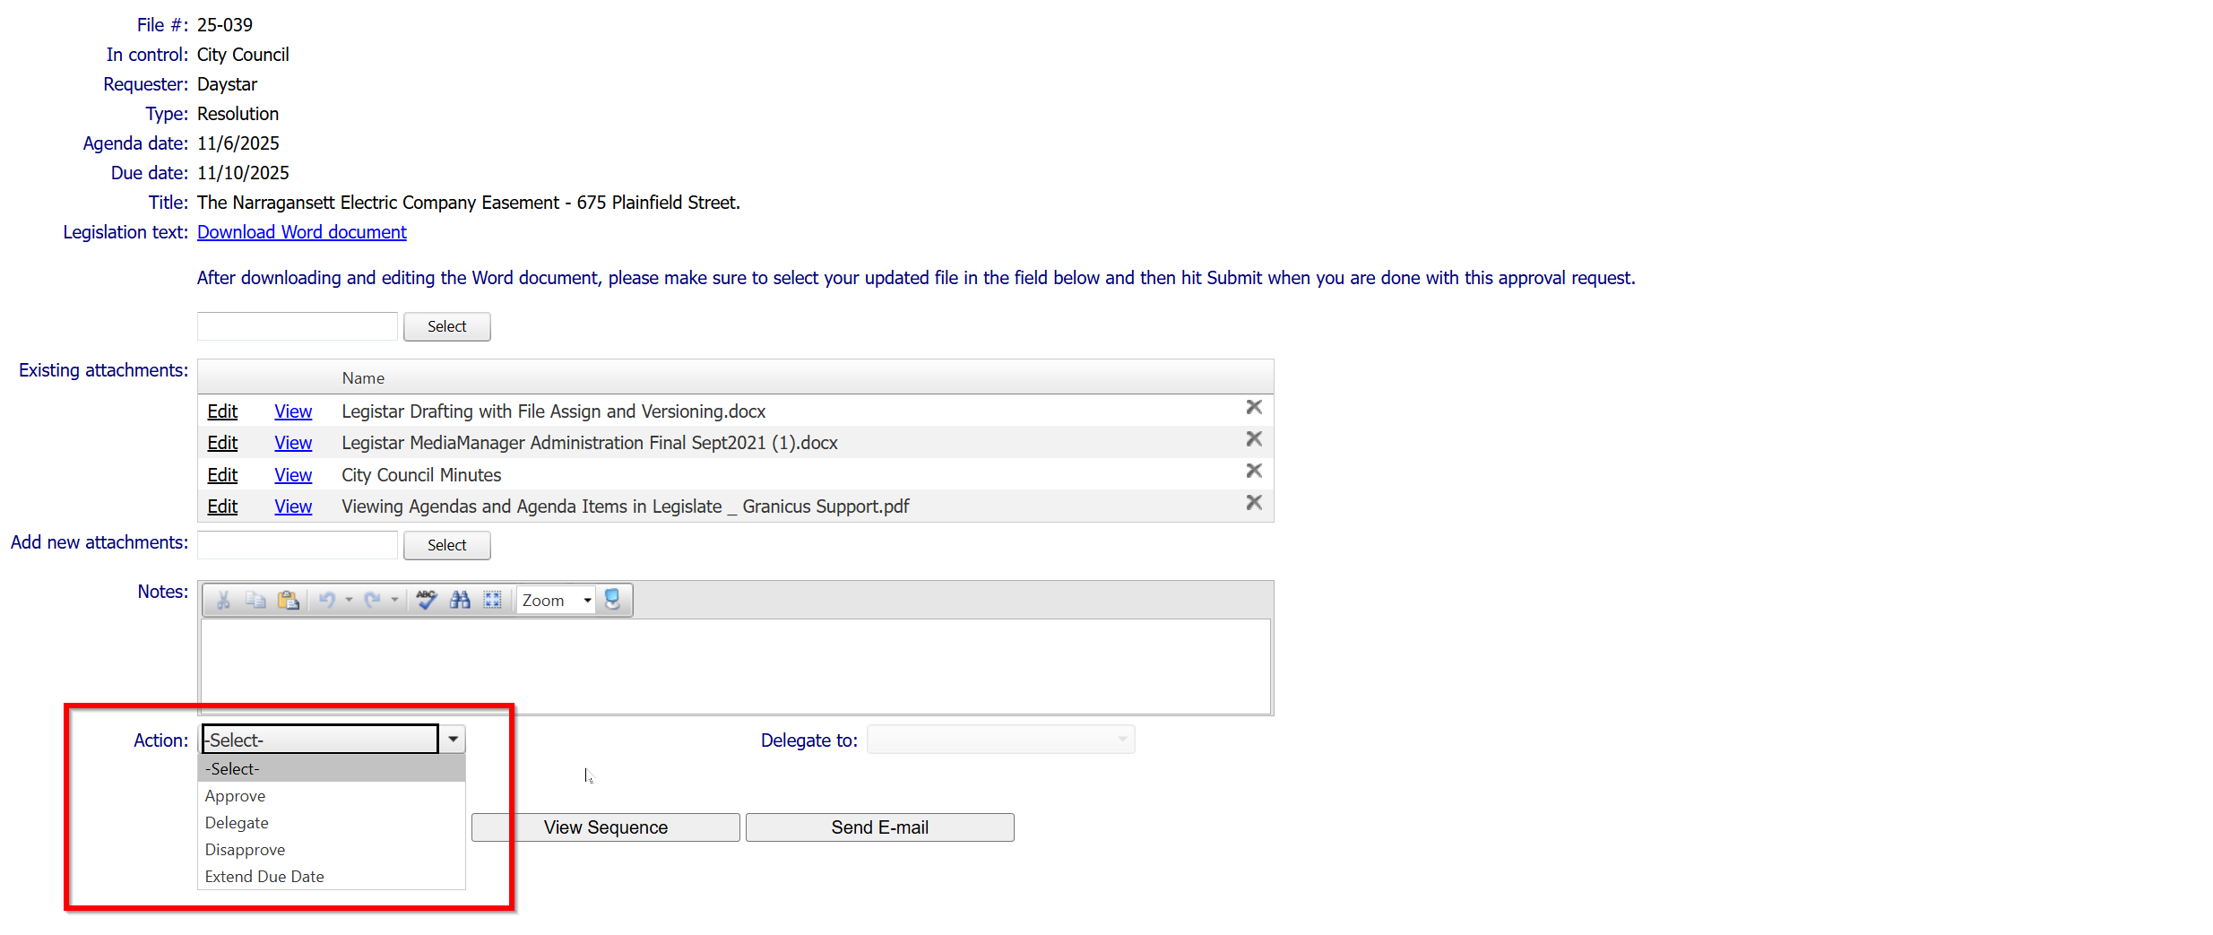

Legistar Local Settings for Approvers
Each individual user has access to Local Settings. While there are many Local Settings available, the Local Settings detailed on this guide are specific to the needs of an Approver.
- To access Local Settings, click the Tools menu on the Home screen and select Local Settings.
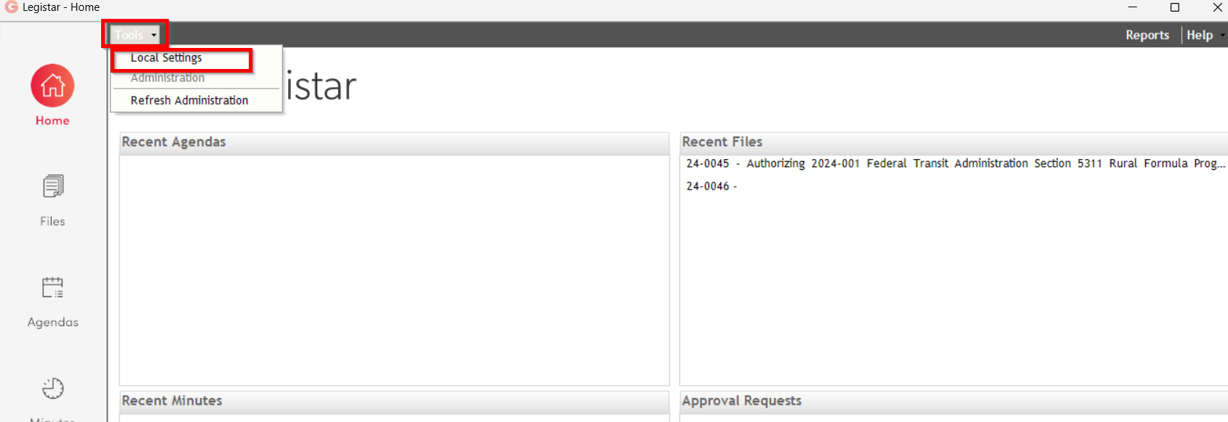
- Change or reset your password on the Password tab. Enter your old (current) password, then your new password twice. To be able to log into InSite your password must be 6 characters minimum. There are not any character rules for setting your password, but please ensure it is something secure. To apply changes, you must click Save.

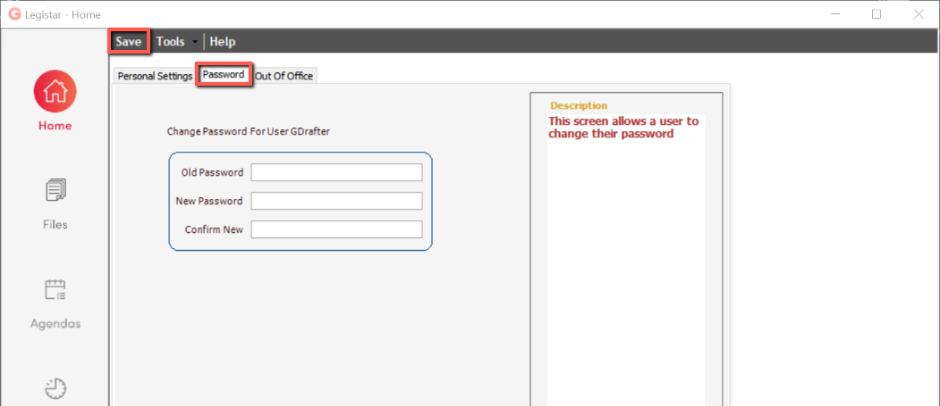
- If you are going to be out of the office, you can assign another individual to receive any items that come to you during your out of office time. They will essentially be your “automatic delegate” to receive your items and act on them while you’re away. Turn on/off your Out of Office setting on the Out of Office tab.
  - Change “Out of Office?” to Yes to turn on the out of office feature.
  - Select the person who should be your Alternate/“automatic delegate” while you are away.
  - To apply changes, you must click Save.
  - Be sure to Refresh Administration when you go to the Home tab.
When you are back in the office, you must remember to come back to this Local Settings and set “Out of Office?” back to No, then click Save to turn your out of office feature off and allow items to come to you again.

