TOWN of ALTONA
HOMETOWN HEROES

Created by the Town of Altona to recognize and honor residents who have served or who are serving in the United States Armed Services.

This program is non-political and non-partisan and is intended to serve as a living memorial to those service men and women from the Town of Altona.

As an ongoing program, applications will be accepted at any time by those who wish to sponsor a banner. Banners shall be displayed from May to November and measure 36” x 72”. Banners will be displayed and stored by the Town for a 2 year period and returned to the applicant at time of decommission. After all available spaces are filled, a waitlist will be maintained on a first come first served basis.

TO PARTICIPATE
Street banners will be installed honoring Town of Altona residents (past or present) who meet the requirements. A completed application and supplemental documents must be provided for review by a committee. Banners are limited to 1 per serviceperson for a fee of $225.

ELIGIBILITY REQUIREMENTS
Honoree must be:
- Military personnel
- Currently serving, honorably discharged, retired or deceased

Honoree must meet one of the following criteria:
- Be a current resident of the Town of Altona
- Have previously lived in the Town as a long-term resident (10 years or more)

Each application is subject to approval by the Altona Hometown Heroes Committee.

BANNER LOCATIONS
Locations for displaying the banners will be determined by the Altona Hometown Heroes Committee. Available space is determined solely by the Town. A map outlining where each banner is hung shall be made available to all residents on the website and at Town Hall.

CONTACT INFORMATION

Town of Altona

P.O. Box 79

Altona, NY 12910

(518) 236-7035
www.townaltonny.gov
monica@townaltonany.gov


Make Checks Payable To:
“Town of Altona
Heroes Fund”

Drop Off OR Mail Completed Form With Payment To:
Town of Altona
3124 Miner Farm Road
Altona, NY 12910


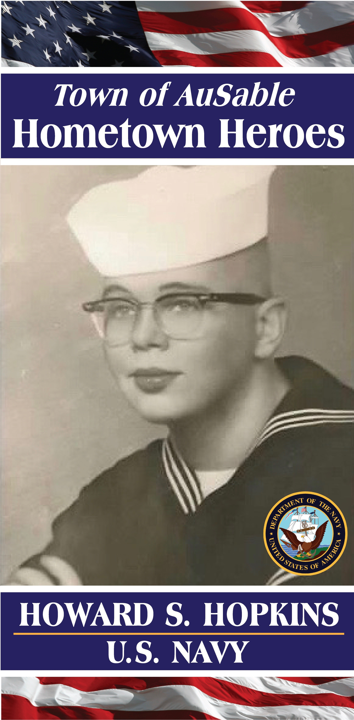
CONTACT INFORMATION
Town of Altona

Town of Plattsburgh
151 Banker Rd.
Plattsburgh, NY 12901
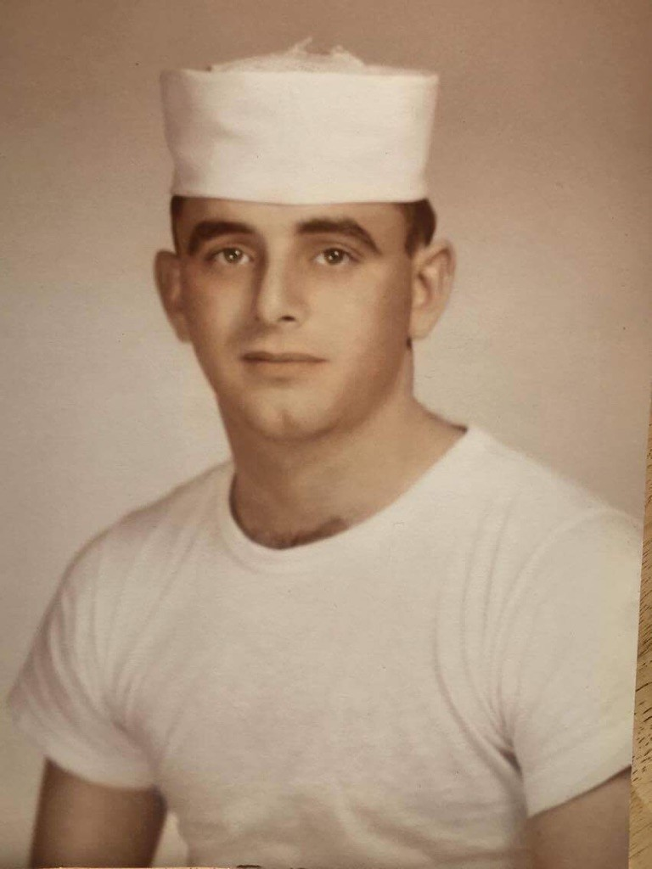

518) 562-6850

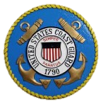

STEPHEN M. IMHOFF

U.S. COAST GUARD

PHOTO OF SERVICE MEMBER
Photo must be at least 300 dpi resolution or the banner may be grainy.
No refunds once produced
Drop off OR email photo to:
monica@townaltonany.gov

HOMETOWN HEROES APPLICATION
Please Print or Type

YOUR CONTACT INFORMATION
First Name | Last Name
Mailing Address
City | State |  | Zip
Landline | Cellphone
Email
Your Relationship to Honoree:
Parent Child Spouse Sibling Self Grandparent Cousin Aunt/Uncle Niece/Nephew Friend
SERVICE MEMBER INFORMATION
First Name |  | Middle Initial or Name (if desired)
Last Name |  | Town of  Altona
Branch of Service
Army Navy Marine Corps Air Force Coast Guard Army National Guard Air National Guard
Purple Heart Recipient
TO FULFILL BANNER ORDER
Drop off or Mail the following documents:
- Completed Application
- Proof of Residency
- Proof of Honorable Discharge/ Active Service
- Check or Money Order for $225; make payable to “Town of Altona Heroes Fund”
Mail to: Town of Altona, P.O. Box 79 Miner Farm Road, Altona, NY 12901 Attn: Mindy Guerin
Photo of Service Member Drop Off or Email to:
mindy@townaltona.com
OFFICE USE ONLY
Date Received | Received By
Check / Money Order # | Total Payment Received
Documents Received
Application Proof of Residency/Graduation Proof of Honorable Discharge/Active Service



