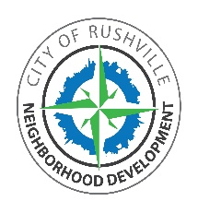 City of Rushville 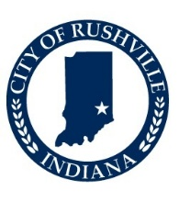
Neighborhood Development
330 North Main Street, Suite 200
Rushville, Indiana 46173
Samantha Copley, Executive Director
Planning and Zoning
Code and Building Compliance

Notice is hereby given of the following regularly scheduled meetings of the City of Rushville Historic Board:

07 January 2026
04 February 2026
04 March 2026
01 April 2026
06 May 2026
03 June 2026
01 July 2026
05 August 2026
02 September 2026
07 October 2026
04 November 2026
02 December 2026

The Historic Board meeting shall commence at 7:00 p.m. The meeting will be held in Council Chambers, 330 N. Main Street, Suite 200, Rushville, Indiana 46173.

