RESOLUTION NO. 26 –

Resolution of the Board of Supervisors of the County of Humboldt REVOKING Talking Trees Farms Conditional use permit, Record Number PLN-13198-CUP for APN 522-174-034.

WHEREAS, On, December 30, 2016, Craig Nejedly submitted an application for a Conditional Use Permit for cannabis cultivation on APN 522-174-034; and
WHEREAS, on June 22, 2018, the permit was approved for an existing 25,200 square feet outdoor cannabis cultivation; and
WHEREAS, on December 9, 2025, Board of Supervisors directed the Planning and Building Department to schedule revocation hearings for all permits that had not entered a payment plan and still owed Measure S taxes as of December 31, 2025; and

WHEREAS, this permit holder has unpaid Measure S taxes of $29,916.18 and did NOT establish a payment plan for those taxes owed; and
WHEREAS, a letter was sent to the permit holder on January 28, 2026, notifying them that the permit had been suspended for unpaid Measure S taxes, and that the permit was being scheduled for revocation by the Board of Supervisors; and

WHEREAS, the January 28, 2026, letter identified that if the Measure S taxes were paid by March 31, 2026, the permit would be removed from the agenda for consideration of permit revocation; and

WHEREAS, the required Measure S taxes had not been paid by March 31, 2026; and

WHEREAS, the Board of Supervisors held a duly-noticed public hearing on May 12, 2026, and reviewed, considered, and discussed the revocation for this Conditional Use Permit and reviewed and considered all public testimony and evidence presented at the hearing.

NOW, THEREFORE, IT IS HEREBY PROCLAIMED that the Board of Supervisors makes all the following findings:

1. | FINDING: |  | Project Description: Revocation of a Conditional Use Permit for cannabis cultivation on APN 522-174-034 for lack of payment of processing costs and not addressing the Measure S obligations associated with the permit.
 | EVIDENCE: |  | Project File: PLN-13198-CUP
 |  |  | Humboldt County Code Section 312-14.2 allows revocation of a permit when the permit has been exercised contrary to the terms and conditions of the permit or in violation of any statute, code section law or regulation.
2. | FINDING: |  | CEQA: The requirements of the California Environmental Quality Act have been complied with as this action is exempt from environmental review.
 | EVIDENCE: |  | CEQA Guidelines Section 15321 exempts enforcement actions by a regulatory agency including actions to revoke permits.
3. | FINDING: |  | The permit has been exercised contrary to the terms and conditions of approval and/or in violation of the County Code.
 | EVIDENCE: |  | Section 55.4.11 (a) of the Commercial Medical Marijuana Land Use Ordinance states: Cannabis cultivation and other commercial cannabis activity shall be conducted in compliance with all laws…
 |  |  | Section 55.4.3.8 of the Humboldt County Code states “Zoning clearance certificates and permits issued for commercial cannabis activities pursuant to the commercial medical marijuana land use ordinance (CMMLUO) as set forth in this section shall remain valid, and shall be governed by the terms and conditions of this section until such time as the permit is modified” thus references to the CMMLUO are treated as sections of the Humboldt County Code for permits issued under the CMMLUO.
 |  |  | Section 719-4 of the Humboldt County code states: In addition to any requirements imposed by Title III, each person issued a commercial marijuana cultivation permit shall pay an annual tax of one dollar ($1.00) per square foot of outdoor cultivation area, two dollars ($2.00) per square foot of mixed-light cultivation area or three dollars ($3.00) per square foot of indoor cultivation area. The permit holder is responsible for paying the taxes imposed under this section of the code.
 |  |  | The permit holder has failed to pay required Measure S taxes as outlined in Humboldt County Code This sum currently amounts to $29,916.18.
4. | FINDING: |  | Notice of this hearing was given as required by Section 312-14.2.6 of the Humboldt County Code and Section 65091 of the California Government Code.
 | EVIDENCE: | - 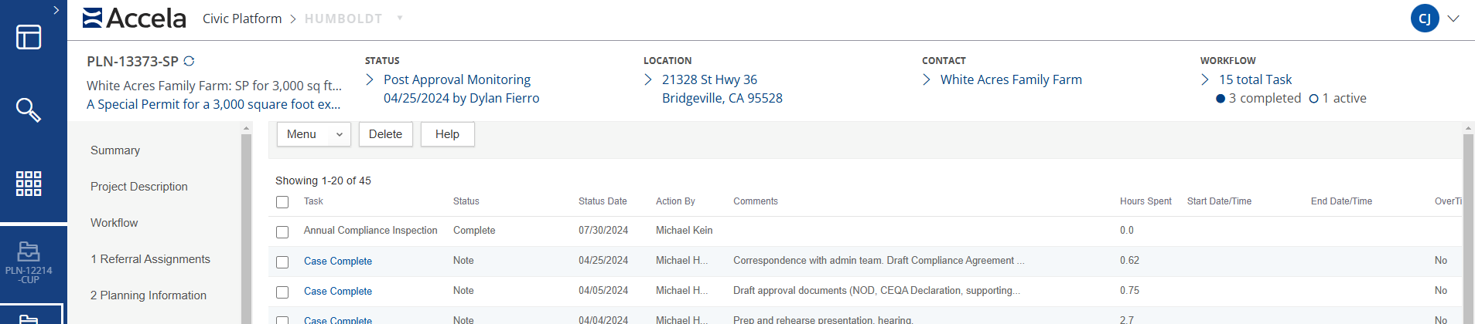 | A Notice of Revocation Hearing was sent to the permit holder’s address on record on April 22, 2026, by certified, return requested mail, as required by Section 312-14.2.6 of the Humboldt County Code.
 |  |  | A Notice of Public Hearing was sent to the permit holder, property owner and agent, and all property owners and occupants of record within 300 feet and was published in the local newspaper on April 22, 2026, as required by Section 65091 of the California Government Code.

DECISION
NOW, THEREFORE, based on the above findings and evidence, the Board of Supervisors does hereby:
a. Revoke the Conditional Use Permit for APN 522-174-034.
The foregoing Resolution is hereby passed and adopted by the Board of Supervisors on May 12, 2026, by the following vote:

Dated:
Supervisor Mike Wilson, Chair
Humboldt County Board of Supervisors

Adopted on motion by Supervisor , Seconded by Supervisor , and the following vote:
AYES: Supervisors: --
NAYES: Supervisors: --
ABSENT: Supervisors: --
ABSTAIN: Supervisors: --

STATE OF CALIFORNIA
County of Humboldt

I, Kayliegh Maffei, Clerk of the Board of Supervisors, County of Humboldt, State of California, do hereby certify the foregoing to be a full, true, and correct copy of the original made in the above-entitled matter by said Board of Supervisors at a meeting held in Eureka, California as the same now appears of record in my Office.

IN WITNESS WHEREOF, I have hereunto set my hand and affixed the Seal of said Board of Supervisors.

___________________________________
Kayliegh Maffei
Clerk of the Board of Supervisors of the County of Humboldt, State of California

