Scott County Fiscal Court held a meeting on Tuesday, November 26, 2024. Judge Covington called the meeting to order. Present were Magistrates Mr. Hostetler, Mr. Jones, Mr. Wallace, Mr. Corman, Mr. Ellison, Mr. Pratt, Mr. Livingston, and County Attorney, Cam Culbertson.
A motion was made by Mr. Hostetler with second by Mr. Jones to approve the previous meeting minutes (11/8, 11/12). Court voted unanimous.
A motion was made by Mr. Corman with second by Mr. Pratt to approve the following transfers. Court voted unanimous.
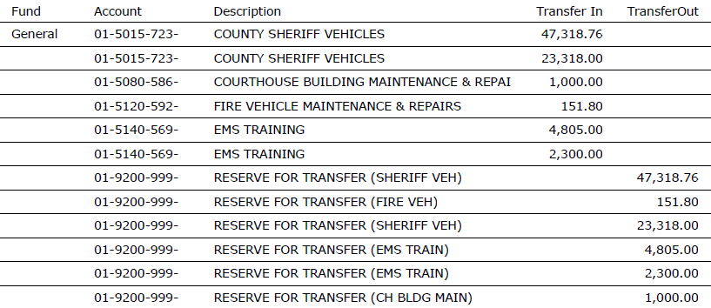
A motion was made by Mr. Livingston with second by Mr. Ellison to approve the bills as presented and the following hand checks. Court voted unanimous.
Road Fund/ General $125,000.00, Capital Fund/ General $1,010,000.00, Jail Fund/ General $300,000.00
Mr. Jones completed his training unit.
Economic Development Director, Jack Conner discussed a grant opportunity through Kentucky Product Development Initiative. Mr. Culbertson read Resolution 24-26; a resolution committing matching funds in the amount of one hundred thousand dollars to Scott County United for Lanes Run Business Park Phase III, provided the grant is awarded. A motion was made by Mr. Wallace with second by Mr. Hostetler to approve the resolution and authorize Judge Covington to sign relevant documents. Court voted unanimous.
Mallard Point Homeowners Association President, Leigh Dotson spoke about a continuous speeding issue in the neighborhood. On behalf of Mallard Point Board of Directors, she requested speed bumps near the park and stop signs in other areas. After much discussion, court members agreed on three stop signs.
Jailer Broyles presented the Scott County Detention Center quarterly report. He discussed inmate population, a NET Recovery service proposal, and an upcoming maintenance position.
Fire Chief, John Ward requested to promote Adam White to Battalion Chief at $24.83 per hour, Jeremy Barnett to Captain at $21.88 per hour, and Mark Bennett to Lieutenant at $19.04 per hour. A motion was made by Mr. Pratt with second by Mr. Jones to approve the promotions. Court voted unanimous.
On behalf of Animal Control Director, Sherry Bishop, Human Resources Director, Jeff Mudrak requested to promote Brianna Thompson to Senior Animal Control Officer at $22.31 per hour. A motion was made by Mr. Hostetler with second by Mr. Jones to approve the promotion. Court voted unanimous.
Mr. Corman exited.
EMS Director, Chris Runyon requested to promote Cameron Wilson from Advanced EMT to Paramedic at $17.90 per hour. A motion was made by Mr. Hostetler with second by Mr. Jones to approve the promotion. Court voted unanimous.
Mr. Runyon requested to hire Isabella Butler, Shelby Hale, Kylie Sklavos, and Michael Underwood full-time at $14.14 per hour. Also, he requested to hire Zackary Cornett part-time at $12.40 per hour and Allison Loosle part-time at $14.79 per hour. A motion was made by Mr. Wallace with second by Mr. Hostetler to approve the new hires. Court voted unanimous.
The court accepted sealed bids for cameras and access control at the new EMS office. Bates Security, Southeast Banking Systems, Trace 3, Bluegrass Home Entertainment Judge Covington reviewed the top two bids; Bates is less year one, Southeast Banking Systems is less each year after. IT Director, Chip Clark was available for questions. A motion was made by Mr. Pratt with second by Mr. Wallace to approve the bid from Southeast Banking Systems. Court voted unanimous.
Judge Covington presented an agreement with Bluegrass Area Development District for maintaining the transfer station voucher webpage. Solid Waste Coordinator/ Deputy Judge Executive, Jared Hollon was available for questions. A motion was made by Mr. Hostetler with second by Mr. Jones to approve the agreement. Court voted unanimous.
Coroner, Mark Sutton requested to surplus and donate a body cooler to Harrison County; the cooler is approximately ten years old and needs to be repaired. A motion was made by Mr. Hostetler with second by Mr. Jones to declare the items as surplus and approve the donation. Court voted unanimous.
A motion was made by Mr. Jones with second by Mr. Pratt to follow the state holiday schedule for 2025. Court voted unanimous.
Judge Covington discussed an economic development proposal with Madison County and City of Berea. He stated funds are reserved for a regional development project; however, a resolution is required. There will be a special meeting on December 4th at 5:30PM to present the resolution.
A motion was made by Mr. Wallace with second by Mr. Jones to adjourn for executive session pursuant to KRS 61.810 (1C) That is to discuss proposed or pending litigation against or on behalf of the public agency. Court voted unanimous.
A motion was made by Mr. Pratt with second by Mr. Jones to come out of executive session. Court voted unanimous.
Judge Covington stated no action was taken in executive session.
A motion was made by Mr. Hostetler with second by Mr. Jones to adjourn. Court voted unanimous.

