Scott County Fiscal Court held a meeting on Thursday, August 28, 2025. Judge Covington called the meeting to order. Present were Magistrates Mr. Hostetler, Mr. Jones, Mr. Wallace, Mr. Corman, Mr. Ellison, Mr. Pratt, Mr. Livingston, and County Attorney, Cam Culbertson.
A motion was made by Mr. Jones with second by Mr. Livingston to approve the previous meeting minutes (7/24 & 8/18). Court voted unanimous.
A motion was made by Mr. Corman with second by Mr. Ellison to approve the following transfers. Court voted unanimous.
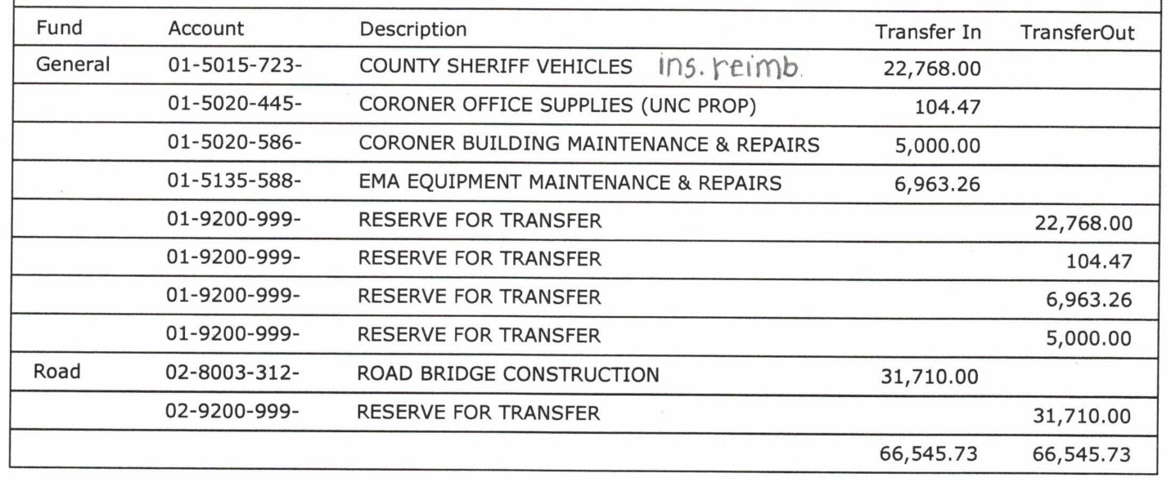
A motion was made by Mr. Hostetler with second by Mr. Wallace to approve the bills as presented and the following hand checks. Court voted unanimous.
Road Fund/ General $500,000.00, Jail Fund/ General $500,000.00, Capital Fund/ General $282,000.00, Noble View/ General $2,374.19
Clerk fees were submitted in the amount of $206,519.02; fees were submitted on/by August 10th.
EMS Director, Chris Runyon introduced the department’s emotional support dog, Sadie.
Library Director, Elizabeth Kozlowski presented the library tax rates; (per $100) real estate tax .044 and tangible/personal property tax .0487. Court members acknowledged receipt of the tax rates.
Health Board representative, Jared Hollon was present for the public health district tax rates; (per$100) real estate tax .044 and tangible/personal property tax .044. Court members acknowledged receipt of the tax rates.
Cooperative Extension representative, Judge Covington presented the extension tax rates; (per $100) real estate tax .0149 and tangible/personal property tax .0281. Court members acknowledged receipt of the tax rates.
Judge Covington presented the county tax rates; (per $100) real estate tax .0528 and tangible/personal property tax .0511. A motion was made by Mr. Ellison with second by Mr. Jones to approve the rates. Court voted unanimous.
A motion was made by Mr. Wallace with second by Mr. Corman to approve the tax rate (per $100) at .166 for motor vehicle & watercraft. Court voted unanimous.
Judge Covington discussed the option for street-legal special purpose vehicles (SLSPV). Citizens Mark Smith, Duane Power, and Cody Meadows spoke in favor of SLSPV. Mr. Culbertson gave second reading of Ordinance 25-02; an ordinance determining that it is appropriate to allow street-legal special purpose vehicles on specified highways within the jurisdictional boundaries of Scott County. A motion was made by Mr. Hostetler with second by Mr. Jones to approve second reading. Voting Yes: Mr. Hostetler, Mr. Jones, and Mr. Pratt. Voting No: Mr. Wallace, Mr. Corman, Mr. Ellison, Mr. Livingston, and Judge Covington. Motion failed.
Mr. Hostetler exited.
EMS Director, Chris Runyon requested to hire Madeline Kincaid at $19.45 per hour, Patrick Boyken at $14.56 per hour, Teb Jagger at $19.45 per hour, Emily Mather at $12.77 per hour, and Chris Perry at $12.77 per hour. A motion was made by Mr. Jones with second by Mr. Ellison to approve the new hires. Court voted unanimous.
Road Department Director, JR Brandenburg requested to hire Bruno Ruvalcaba at $25.76 per hour. A motion was made by Mr. Ellison with second by Mr. Wallace to approve the new hires. Court voted unanimous.
Judge Covington presented a lease from Kentucky Department for Facilities for Commonwealth Attorney office space on North Hamilton (old sheriff's office). Unified Prosecutorial System has agreed to pay $54,119.00 annually plus utilities and custodial services. A motion was made by Mr. Jones with second by Mr. Corman to approve the agreement. Court voted unanimous.
Mr. Culbertson read Resolution 25-14; a resolution authorizing GMWSS to act as an agent for Scott County Fiscal Court regarding community projects grant funding for sewer improvements to Northern Scott County. A motion was made by Mr. Pratt with second by Mr. Ellison to approve the resolution. Court voted unanimous.
Judge Covington stated he learned that staff at Isaiah House (Georgetown branch) vacated the facility and no services have been offered. He suggested sending written notice of termination as they have breached the agreement. A motion was made by Mr. Corman with second by Mr. Ellison to terminate the agreement. Court voted unanimous.
Judge Covington requested to change the September 5th work session to September 4th. A motion was made by Mr. Corman with second by Mr. Pratt to approve the date change. Cour voted unanimous.
A motion was made by Mr. Corman with second by Mr. Livingston to adjourn. Court voted unanimous.

