Scott County Fiscal Court held a meeting on Thursday, September 25, 2025. Judge Covington called the meeting to order. Present were Magistrates Mr. Jones, Mr. Wallace, Mr. Corman, Mr. Pratt, Mr. Livingston, and County Attorney, Cam Culbertson.
A motion was made by Mr. Pratt with second by Mr. Corman to approve the previous meeting minutes (9/12 & 9/22). Court voted unanimous.
A motion was made by Mr. Wallace with second by Mr. Jones to approve the following transfers. Court voted unanimous.
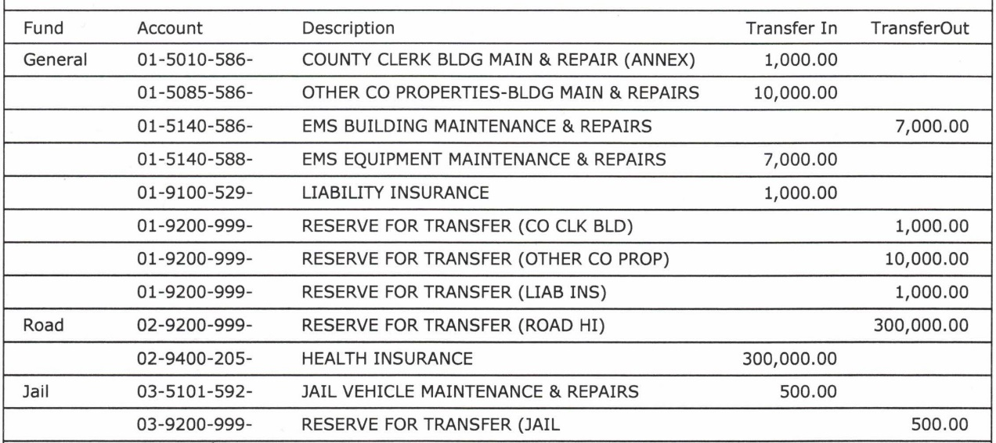
A motion was made by Mr. Pratt with second by Mr. Jones to approve the bills as presented and the following hand checks. Court voted unanimous.
Road Fund/ General $600,000.00 Capital Fund/ General $50,000.00 (ratify)
Mr. Livingston arrived via Zoom.
Economic Development Director, Jack Conner presented a proclamation recognizing October as manufacturing month.
Mr. Culbertson read a proclamation honoring EMS Battalion Chief, Jennifer Wright and congratulating her on retirement.
Judge Covington gave EMS Director, Chris Runyon permission to apply for a grant that had a deadline prior to this meeting; he is requesting retroactive approval. A motion was made by Mr. Wallace with second by Mr. Corman to approve application. Court voted unanimous.
Mr. Runyon requested to promote McKayla Brandenburg to EMS Battalion Chief at $24.24 per hour. A motion was made by Mr. Jones with second by Mr. Pratt to approve the promotion. Court voted unanimous.
EMA Director, Michael Hennigan requested permission to attend training in Texas. There is no cost to the county. A motion was made by Mr. Corman with second by Mr. Jones to approve the out-of-state travel. Court voted unanimous.
Judge Covington presented agreements to shift remaining funds from the Mount Horeb bridge project to the North Rays Fork bridge project. A motion was made by Mr. Livingston with second by Mr. Jones to approve the agreements. Court voted unanimous.
A motion was made by Mr. Jones with second by Mr. Pratt to set trick-or-treating for Thursday, October 31st 6:00PM-8:00PM. Court voted unanimous.
Jailer Broyles submitted a request to pick up a vehicle purchased from an agency in Pennsylvania. A motion was made by Mr. Livingston with second by Mr. Corman to approve the out-of-state travel. Court voted unanimous.
Mr. Runyon stated a company submitted a Certificate of Need (CON) for ground ambulance services in nine counties including Scott County. He suggested submitting a letter opposing the CON. A motion was made by Mr. Jones with second by Mr. Wallace authorizing Mr. Culbertson to submit a letter of opposition. Mr. Pratt abstained due to a possible business affiliation. Court voted unanimous.
Judge Covington announced the recent burn ban has been rescinded.
A motion was made by Mr. Wallace with second by Mr. Livingston to adjourn. Court voted unanimous.

